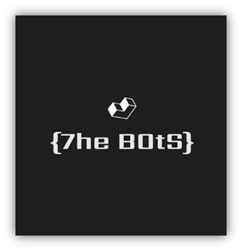

Team members:

Dimitar Bodurov (Scrum Trainer) DTBodurov19@codingburgas.bg

Velimir Dimitrov (Front-end Developer) VVDimitrov19@codingburgas.bg

Zahari Bonev (Back-end Developer) ZNBonev19@codingburgas.bg

Andrei Andreev (Q&A) AGAndreev19@codingburgas.bg

# Navigation through the whole program

## Menu

When you start the program this is going to be the first thing that you will see. From here you can chose between 3 options: 1-Play Game (to start the game), 2-Rules (the rules of the game), 3-Quit The Game (You should not do that, you should continue playing)

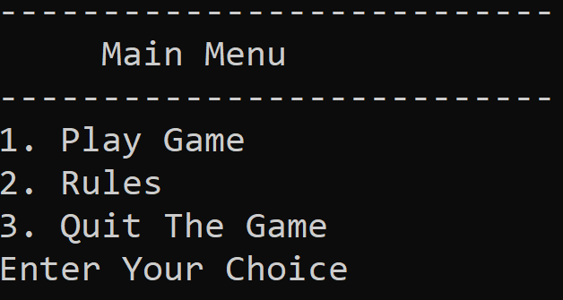

## Play Game

By choosing this option , you will have to choose between playing the levels that were made by us or make one on your own.

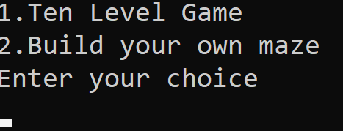

1.2.1 First Option

By choosing the first option , the program will randomly give you one of the ten maps that we made. From there you have to win on the map that has been given to you , to be able to get to the next randomly picked map.(You can’t get the same map twice).

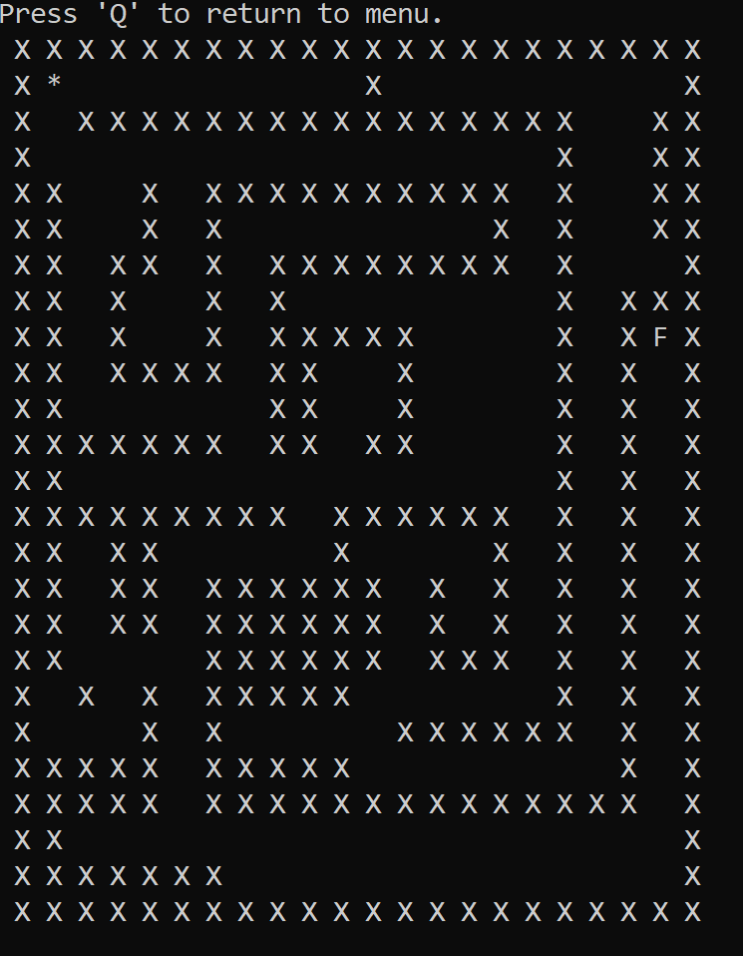

1.2.2 Second Option

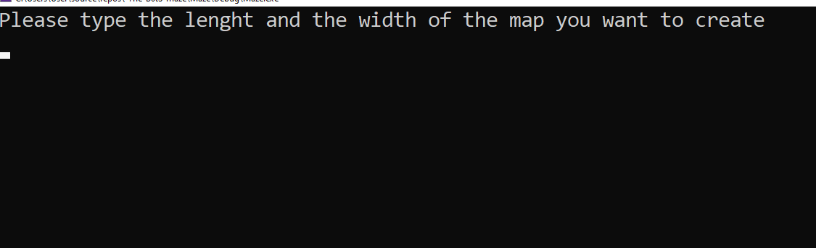

Here you can set the length and the width of your map.

After that you will be shown what to do to complete your maze. And after you win , you will be taken back to the main menu.

# Functions

|  |  |  |  |  |  |
| --- | --- | --- | --- | --- | --- |
| Type of functions |  |  | Name of the function | Parameters | Use |
| unsigned char |  |  | dynamicMapCreator() | a,n,m | Makes the normal arrays into dynamic arrays |
| void |  |  | movement() | map,n,m | Moves The Star |
| void |  |  | userMapCreator() | map,n,m | Creating users maps |
| unsigned char |  |  | userMapStruct() | a,n,m | Build the box |
| unsigned char |  |  | mapDelete() | a,n | Frees the memory |
| void |  |  | randomMapChooser() | / | Picks random map. |
| void |  |  | optionOne() | / | Plays The Map Level Game |
| void |  |  | optionTwo() | / | Build Your Own Maze |
| void |  |  | menu | / | Creates the menu for the program |

# Tests

All maps and functions were tested by hand.

# Stages of realization

* We assembled the team and defined the roles
* We started with the development of the maps
* We made the movement
* We made the main menu
* We made documentation and a presentation

# Difficulties we found in the process of work

The difficulties we overcame during our work were related to the organization of the team and the distribution of time. Fortunately, we were able to clear up these issues and complete our project.

# Additional information

Our program you can find on [Github](https://github.com/DTBodurov19/-7he-B0tS-maze).